Conversational IVR Modernization Framework

Module 1: Legacy System Analysis and Requirements Gathering
Review the architecture and capabilities of existing IVR implementations
1. Introduction to Existing IVR Systems
Interactive Voice Response (IVR) systems are automated telephony solutions that allow organizations to interact with customers over phone calls without human intervention. Traditional IVR systems have been in use for decades in sectors such as banking, telecommunications, insurance, healthcare, travel, and e-governance. These systems are designed to answer common queries, provide information, collect user inputs, and route calls to appropriate departments.
Most existing IVR platforms are implemented using VoiceXML (VXML), a markup language designed for creating voice-based user interfaces. The IVR logic is generally rule-based and follows predefined call flows and menu structures. The caller interacts with the system by pressing keys on the phone keypad (DTMF input) or through limited speech recognition. The IVR processes these inputs and executes the corresponding business logic.
While traditional IVR systems have helped organizations reduce operational costs and handle large call volumes efficiently, they often provide a rigid and menu-driven user experience. This leads to longer call durations and user frustration when the desired option is buried deep within multiple menu levels.

2. Architecture of a Traditional IVR System
A typical legacy IVR system consists of multiple interconnected components that work together to deliver automated voice services:
2.1 Telephony Network (PSTN/VoIP)
This layer connects the caller’s phone to the IVR system. Calls can originate from the Public Switched Telephone Network (PSTN) or Voice over IP (VoIP) networks.
2.2 Voice Gateway / Media Server
The voice gateway acts as a bridge between the telephony network and the IVR application server. It manages call setup, call termination, audio streaming, and protocol conversion.
2.3 IVR Application Server
This server hosts the IVR application logic, typically written in VoiceXML. It controls the call flow, plays prompts, collects user input, and decides the next step in the workflow.

2.4 Prompt Management System
This component stores pre-recorded audio prompts and supports Text-to-Speech (TTS) for dynamically generated messages. It ensures consistent voice responses to users.
2.5 Speech Recognition and DTMF Engine
- DTMF Engine: Captures keypad inputs from users.
- Speech Recognition Engine (ASR): Recognizes limited spoken commands such as “Yes,” “No,” or simple keywords.
2.6 Backend Systems Integration
The IVR integrates with enterprise systems such as:
- Customer Relationship Management (CRM)
- Billing and payment systems
- Databases
- Ticketing and service management systems
This integration allows the IVR to fetch real-time information and perform transactions.

3. Detailed Workflow of an Existing IVR System
The workflow of a traditional IVR system follows a structured, step-by-step call flow:
3.1 Call Initiation
The customer dials a service number provided by the organization. The telephony network routes the call to the IVR system via a voice gateway or media server.
3.2 Call Greeting and Authentication
The IVR plays a welcome message and may request basic authentication information such as:
- Account number
- Registered mobile number
- Date of birth or PIN
This step ensures that the caller is identified before sensitive information is shared.
3.3 Menu-Driven Navigation
The IVR presents a set of menu options. For example:
“Press 1 for Account Balance, Press 2 for Service Requests, Press 3 to Talk to a Customer Representative.”
Users navigate through multiple menu layers based on their requirements.
3.4 Input Collection and Validation
The system captures the user’s input via DTMF tones or simple voice commands. Input validation is performed to ensure correctness. If the input is invalid, the system may repeat the menu or redirect the caller.
3.5 Business Logic Execution
Based on the user’s choice, the IVR executes predefined business logic. This may include querying databases, creating service tickets, or fetching customer-specific information.
3.6 Information Delivery
The IVR delivers the requested information using pre-recorded prompts or text-to-speech. For example, it may announce an account balance, service status, or appointment details.
3.7 Error Handling and Fallback
If the system fails to understand user input or encounters backend issues, it follows fallback logic such as repeating options, redirecting to the main menu, or transferring the call to a human agent.
3.8 Call Termination or Handover
After completing the interaction, the call is either terminated or transferred to a live agent if further assistance is required.

4. Limitations of Existing IVR Systems
- Rigid Interaction Model: Users must follow predefined menus.
- Poor User Experience: Long navigation paths lead to frustration.
- Limited Intelligence: Cannot understand natural language or complex queries.
- High Maintenance Effort: Any change in workflow requires updates to VXML scripts and prompts.
- Low Personalization: Limited ability to provide context-aware responses.

5. Challenges in Maintaining Legacy IVR Systems
- Difficulty in integrating with modern AI platforms
- Complex VXML codebase maintenance
- Limited adaptability to new business requirements
- Growing gap between user expectations and system capabilities
- Dependency on specialized skills for IVR development and support.

Documenting Integration Needs for Alignment with ACS and BAP Platforms
1. Overview
Modernizing legacy IVR systems requires seamless integration between existing VoiceXML (VXML)-based applications and modern Conversational AI platforms such as Azure Communication Services (ACS) for telephony/media handling and Bot Application Platform (BAP) for conversational logic and AI-driven workflows. Proper documentation of integration needs ensures that legacy investments are preserved, migration risks are minimized, and the resulting system is scalable, secure, and maintainable.
This section outlines the technical, functional, and non-functional integration requirements necessary to align traditional IVR systems with ACS and BAP.
2. Integration Scope and Objectives
Objectives of Integration:
- Enable voice call handling through ACS while preserving existing IVR entry points.
- Introduce conversational AI capabilities using BAP for natural language interaction.
- Reuse and extend legacy IVR assets (VXML flows, prompts, backend integrations).
- Ensure a smooth transition with minimal disruption to existing services.
- Provide a foundation for future multi-channel support (chat, web, messaging).
3. Telephony and Media Integration (ACS Layer)
Key Requirements:
- Call Ingress/Egress: Map existing service phone numbers to ACS calling endpoints.
- Media Streaming: Integrate voice streams between ACS and the conversational AI layer.
- Call Control: Support call lifecycle events (answer, hold, transfer, hang-up).
- DTMF Support: Maintain keypad input support for backward compatibility.
- Audio Compatibility: Ensure codec and audio format compatibility between legacy media servers and ACS.
- Failover Routing: Provide fallback routing to legacy IVR or live agents if ACS services are unavailable.
4. Conversational AI Integration (BAP Layer)
Key Requirements:
- Dialog Orchestration: Map menu-based IVR flows to conversational dialog flows in BAP.
- Intent & Entity Design: Define intents (user goals) and entities (key data) aligned with existing IVR use cases.
- Context Management: Maintain conversation state across multiple turns and interruptions.
- Fallback & Escalation: Define rules for handing off to a human agent when confidence is low or the user requests assistance.
- Multilingual Support: Align bot language models with existing IVR language offerings.
5. Legacy Asset Reuse and Mapping (VXML to Conversational Flows)
Key Requirements:
- Flow Mapping: Convert VXML forms, menus, and decision logic into modular conversational components.
- Prompt Reuse: Reuse existing recorded prompts where appropriate; migrate to TTS for dynamic responses.
- Business Rules Reuse: Extract and reuse backend business logic already implemented in legacy IVR services.
- Service Abstraction: Wrap legacy logic into APIs/microservices to decouple from the conversational layer.
6. Backend and Enterprise System Integration
Key Requirements:
- API Enablement: Expose CRM, billing, ticketing, and customer data systems via secure APIs.
- Data Consistency: Ensure consistent data access for both legacy IVR and BAP bots during transition.
- Transaction Handling: Support synchronous and asynchronous service calls with proper error handling.
- Middleware: Introduce an API gateway or middleware layer for orchestration and security.
System Architecture Diagram (Legacy IVR + ACS + BAP)
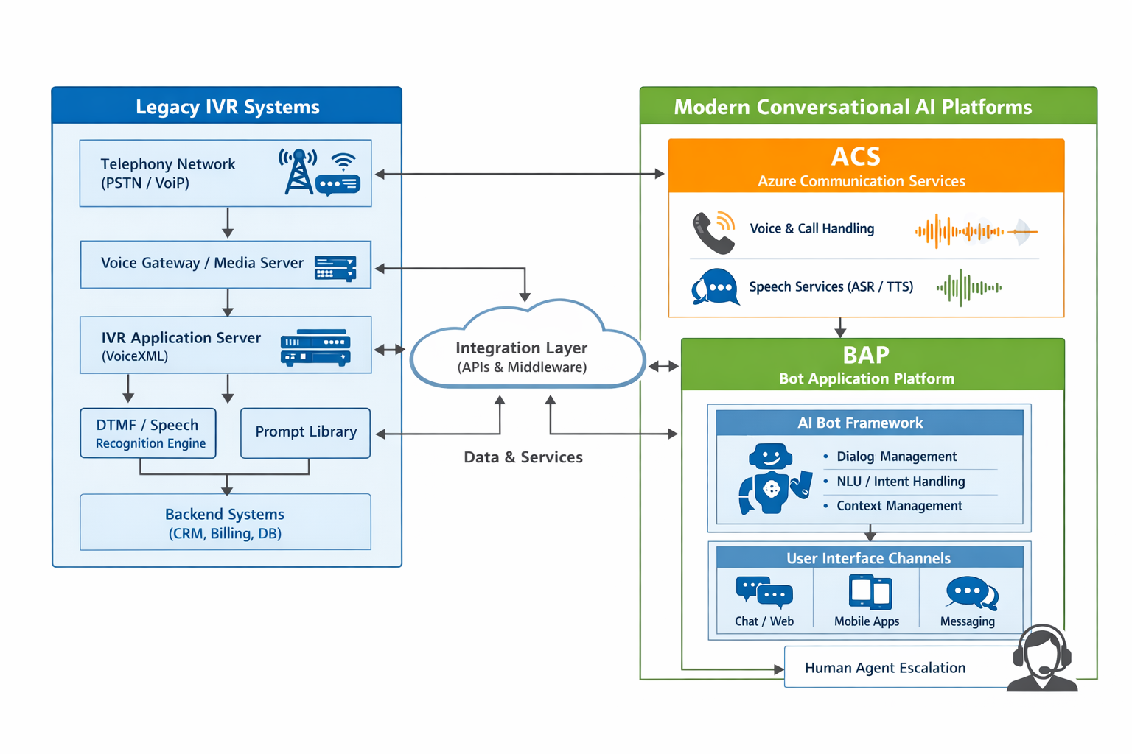

7. Speech Services and Language Processing
Key Requirements:
- ASR Integration: Integrate speech-to-text services for natural language input.
- TTS Integration: Use natural-sounding text-to-speech for dynamic responses.
- Noise Handling: Support noise suppression and confidence thresholds for better recognition accuracy.
- Language Models: Align speech models with supported languages and accents.
Project Deliverables:
- ASR/TTS configuration details
- Language support matrix
- Audio quality and performance benchmarks
8. Security, Privacy, and Compliance
Key Requirements:
- Authentication & Authorization: Secure service-to-service communication between ACS, BAP, and backend systems.
- Data Protection: Encrypt sensitive customer data in transit and at rest.
- Access Control: Role-based access for administrators and operators.
- Compliance: Adhere to organizational and regulatory data privacy requirements.
- Audit Trails: Maintain logs for compliance, debugging, and audits.
Project Deliverables:
- Security architecture diagram
- IAM and access policy document
- Compliance checklist and audit plan
9. Benefits to the Project
- Clear technical blueprint for IVR modernization
- Reduced redevelopment by reusing legacy assets
- Lower migration risk and smoother rollout
- Improved user experience with conversational AI
- Long-term maintainability and scalability.

Technical Challenges, Constraints, and Compatibility Gaps
1. Introduction
Modernizing legacy IVR systems by integrating them with Conversational AI platforms such as ACS and BAP introduces several technical challenges. These challenges arise due to differences in architecture, communication protocols, data formats, and operational models between traditional VoiceXML-based IVR systems and modern AI-driven conversational platforms. Identifying these challenges, constraints, and compatibility gaps early is essential to plan a smooth and low-risk migration strategy.
2. Technical Challenges
2.1 Integration Complexity
Legacy IVR systems are tightly coupled with telephony infrastructure and VXML-based call flows, whereas ACS and BAP follow API-driven, microservices-based architectures. Bridging these two paradigms requires:
- Designing middleware and integration layers
- Managing synchronous (call flow) and asynchronous (API calls) interactions
- Coordinating state between IVR sessions and conversational AI sessions
2.2 Conversation State Management
Traditional IVR systems are largely stateless between menu steps, while conversational AI requires maintaining rich conversational context across multiple turns. Key challenges include:
- Mapping menu-driven states to conversational context
- Preserving session continuity during call transfers and interruptions
- Handling partial user inputs and corrections
2.3 Speech Recognition and Audio Handling
Legacy IVR speech recognition engines are optimized for limited vocabulary and command-based inputs, while modern conversational platforms rely on advanced ASR/TTS models. Challenges include:
- Differences in audio codecs and sampling rates
- Handling background noise and speech confidence thresholds
- Ensuring low-latency, real-time speech processing
2.4 Performance and Latency
Real-time voice interactions are sensitive to delays. Introducing AI processing layers can add latency due to:
- Network calls to ACS and BAP services
- Speech-to-text and text-to-speech processing time
- Backend API response times Maintaining acceptable response times is a critical technical challenge.
2.5 Error Handling and Fallback Mechanisms
Legacy IVR systems use predefined fallback paths (repeat menu, go to main menu, agent transfer). In conversational AI:
- Errors may occur due to low intent confidence, NLU failures, or backend service timeouts
- Designing consistent fallback behavior across both legacy and AI-driven flows is complex

3. System Constraints
3.1 Legacy Technology Constraints
- Dependence on VoiceXML and vendor-specific IVR platforms
- Limited flexibility in modifying existing call flows without regression risks
- Scarcity of skilled resources familiar with legacy IVR technologies
3.2 Infrastructure Constraints
- Existing telephony and media servers may not natively support cloud-based ACS integration
- Bandwidth and network constraints can impact voice quality
- On-premise systems may face limitations in securely exposing APIs to cloud platforms
3.3 Operational Constraints
- High availability requirements restrict downtime during migration
- Need for backward compatibility with existing IVR users during transition
- Limited maintenance windows in production environments
3.4 Compliance and Security Constraints
- Handling sensitive customer data (PII) requires strict security controls
- Regulatory compliance may limit where data can be processed or stored
- Call recording and logging policies may impose additional constraints
4. Compatibility Gaps
4.1 Protocol and Interface Mismatch
- Legacy IVR systems often use telephony protocols and VXML interfaces, whereas ACS and BAP expose RESTful APIs and event-driven interfaces.
- Direct interoperability is not possible without an integration/middleware layer.
4.2 Data Format Incompatibility
- IVR systems exchange data in proprietary or XML-based formats, while modern platforms use JSON and API contracts.
- Data transformation and schema mapping are required.
4.3 Workflow Model Differences
- Menu-driven, linear workflows in IVR do not directly map to dynamic, intent-driven conversational flows.
- Existing decision trees must be re-modeled into conversational dialog graphs.
4.4 Speech Engine Differences
- Legacy speech engines support limited grammars, whereas conversational AI expects free-form speech.
- This gap impacts recognition accuracy and requires retraining or reconfiguration of speech models.
4.5 Authentication and Security Model Gaps
- Older IVR systems may rely on basic authentication or network-level security, while ACS and BAP use modern identity, token-based authentication, and role-based access control.
- Security models must be aligned without weakening existing controls.

5. Conclusion
The modernization of legacy IVR systems involves addressing multiple technical challenges, system constraints, and compatibility gaps that arise from architectural, technological, and operational differences between traditional IVR platforms and modern conversational AI solutions such as ACS and BAP. By systematically identifying these gaps—across integration, speech processing, workflow modelling, security, and performance—organizations can design appropriate mitigation strategies and ensure a smooth, low-risk transition toward AI-driven conversational experiences.

